How to: Intake Removal

I would like to give a "How to" for the intake manifold removal. I am not a mechanic by trade but like to do things myself. If I screw anything up please let me know. I am taking off the manifold to do the TGV deletes and install a APS turbo intake but will only be covering the intake manifold removal part as there already is a how to for TGV deletes and the instructions for the APS inlet install is covered on the APS websight in very good detail.
I used the Manual to do the job (you should pick one up to) but I find that the pictures in the manual sometimes are difficult to understand. It seemed crazy at first with everything you had to unplug to get this thing off but I soon realized that the whole fuel rails and wiring system is connected to the underneath of the manifold. So it all has to come off with it.
I also marked the hoses so I can remember where they go. No need to mark the electrical connections as they are all different and can only connect to their correct partner.
This removal took me about 4 to 5 hours cause I took my time and tried to be careful.
O.K.
1. You need to release the fuel pressure. The fuel pump plug is at the foot of the passenger side behind the kick panel on the right. A plastic screw and a pop pin hold the panel in place. Remove the panel and unplug the green connector. Do this while the car is running and it will stall out in a couple of seconds. I unplugged it first then tried to start the car but it wouldn't run so I unplugged it while it ran just to be sure.
Now open your gas cap to let the pressure out of the tank.
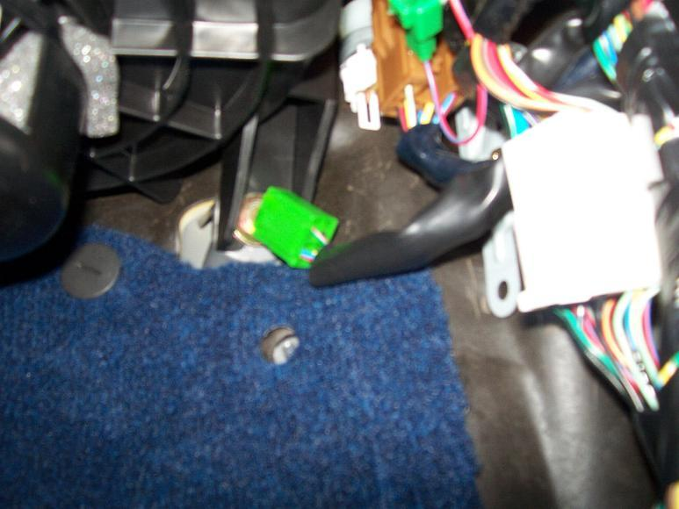
2. Disconnect the negative battery termainal.
3. Now jack up the front of the car or use ramps(don't foget safety stands) Remove the plastic under cover then drain approx 3 litres/3.2 quarts from the rad by using the drain plug on the lower right of the rad. Loosen the rad cap too
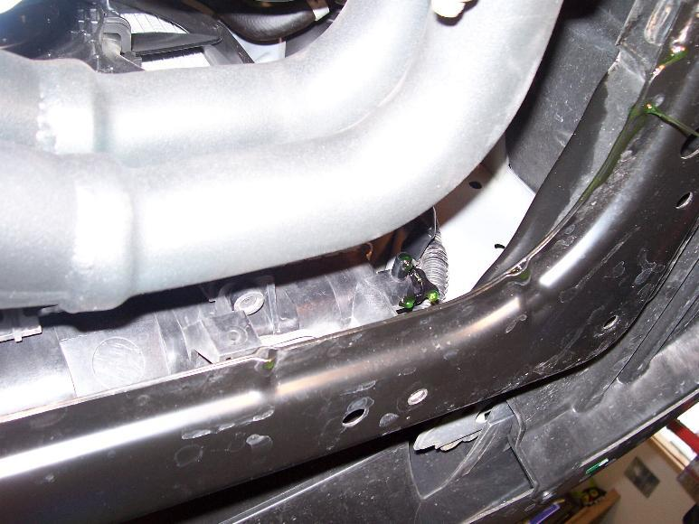
4. Remove the the intire air box and the air intake boot.
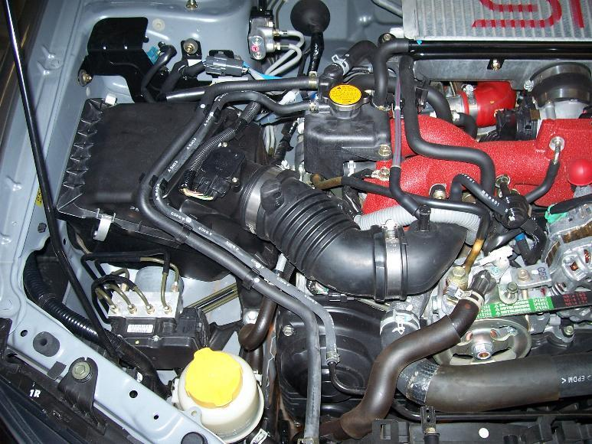
5. Remove the intercooler (There is also a "How to" for this if you need it) You need to remove the BOV and the hose that connects to the turbo intake. I seperated the BOV from the intercooler and then I found that removing the Throttle body first from the intake allowed you better access to the BOV hose clamp on the turbo intake side. You will need to disconnect the coolant lines from the throttle body first. Some antifreeze dribbles will come out here as well.
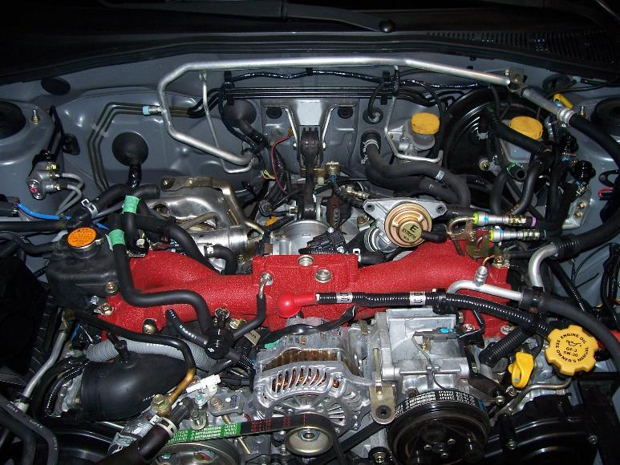
6. Remove the coolant filler tank (black tank on top of the motor on the left) It should be emty but may have some dribbles of antifreeze still in it.
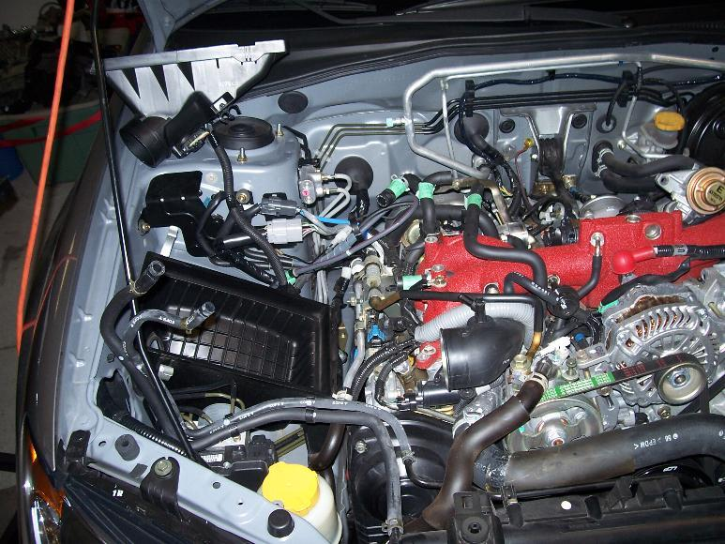
7. Remove the power steering belt. I removed the upper rad hose also just to get it out of the way.
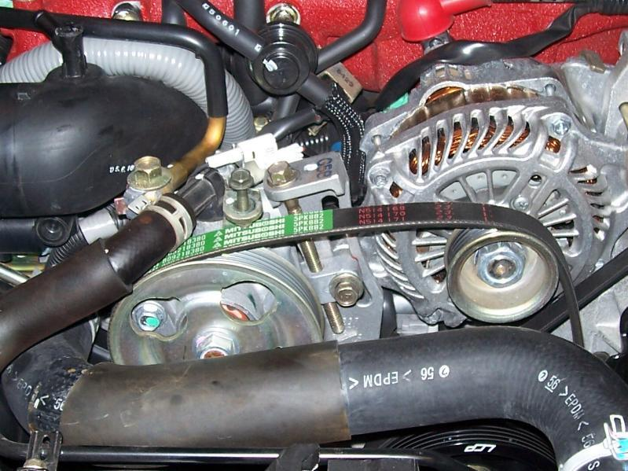
Disconnect the switch controller to the power steering pump(at the pump).
Remove the bolts that hold the pump to the Manifold ( I think theres 3). If you follow the power steering lines to the side of the motor there are brackets attaching the hoses to the engine remove these as well. DO Not Disconnect the fluid lines from the pump.
Pop up on the power steering tank to remove it from its bracket and swing carefully the whole pump assembly over to the wheel well area to get it out of the way be carefull not to bend the lines.
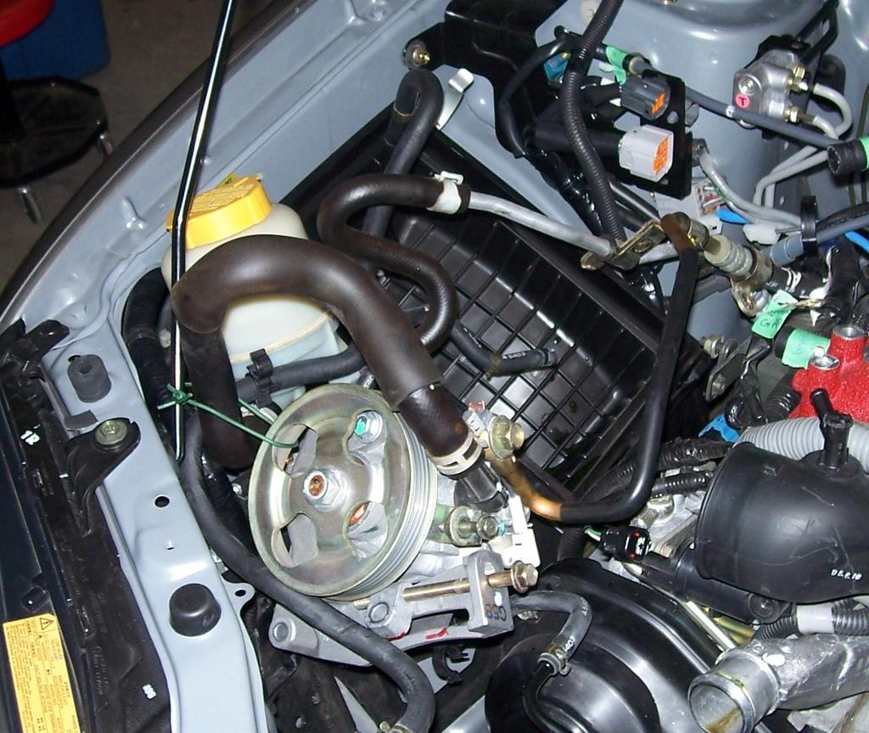
8. Disconnect the PCV hose and electric connector.
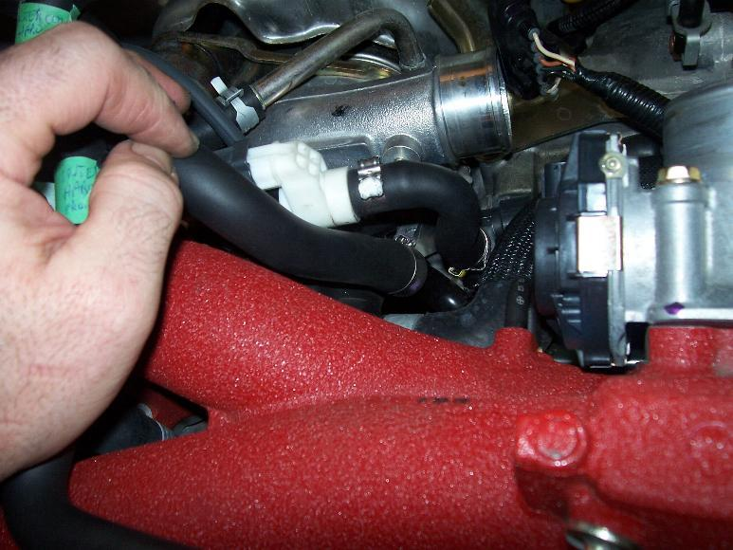
9. Disconnect the brake boost hose.
10. Disconnect the pressure hose from the front/top of the turbo intake.
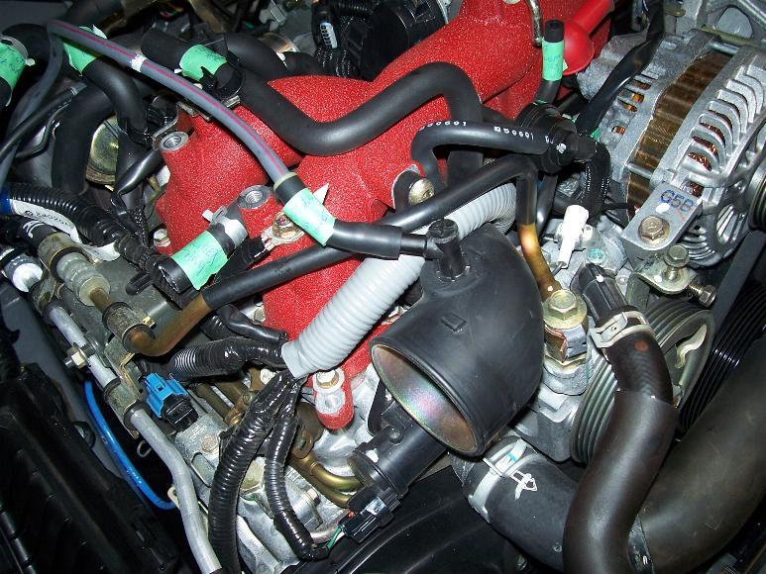
11. Disconnect the engine harness wires from the passeger side.
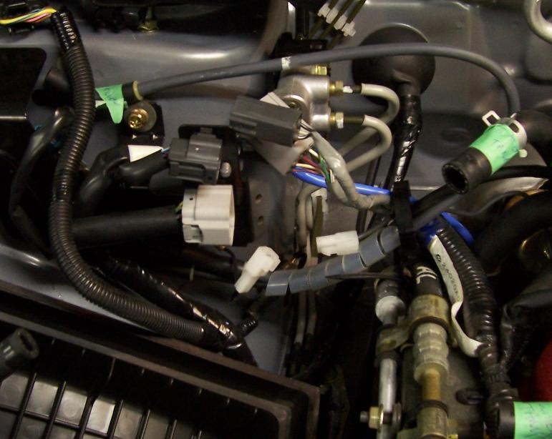
12. Disconnect the other end of the harness by the rear/side of the battery.
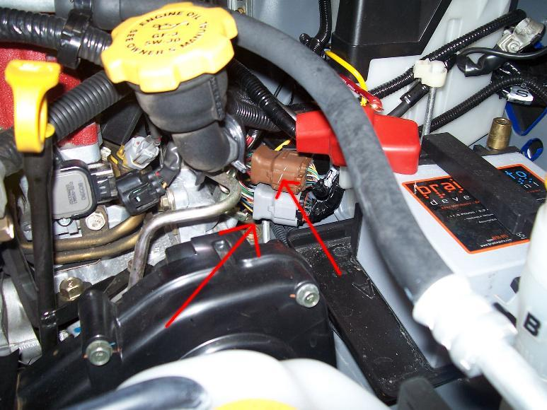
13.From the area under where the power steering used to be, disconnect the connections to the motor. They are the coolant temp. sensor/oil pressure sensor and the crankshaft position sensor.
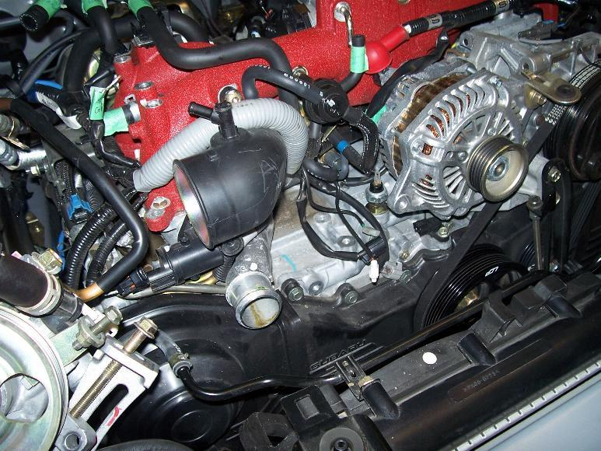
14. Disconnect the knock sensor( I beleive its the brown plug underneath where the throttle body used to sit.)
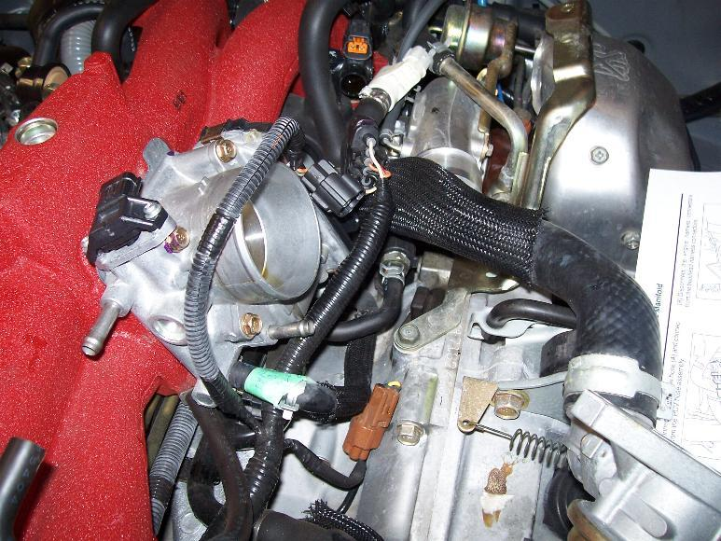
15. Disconnect the camshaft position sensor.
16. Disconnect the connectors to the ignition coils(on top of the spark plugs)
disconnect the harness from the valve/cam cover.
17. In the manual they want you to disconnect the fuel lines by using the special tool but I just unscrewed the clamps that are further up the fuel lines (toward the brake master cylinder) some fuel will dribble out so have a rag handy.
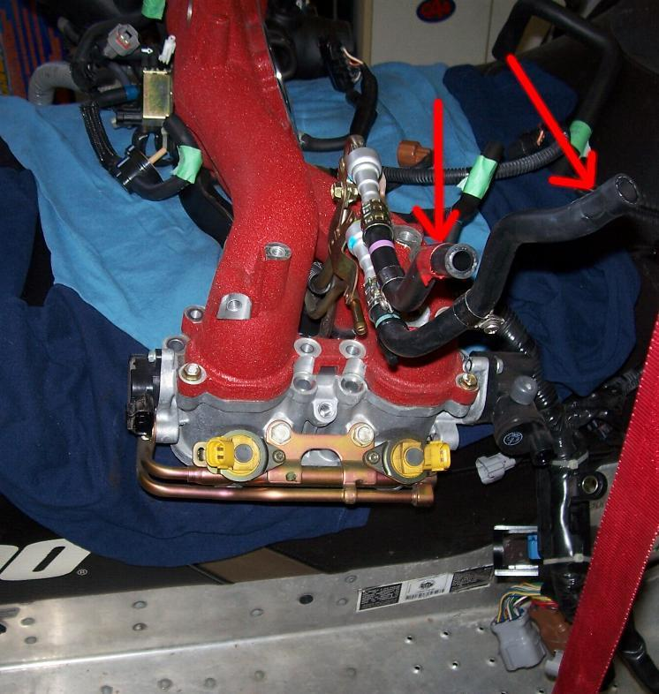
18. Remove the bolts that hold the TGV risers to the head there are 2 for each cylinder (they are pretty tight) Do not remove the intake from the TGV risers first(like I did) cause you need to get it all off first then seperate the TGV risers after its on the bench.
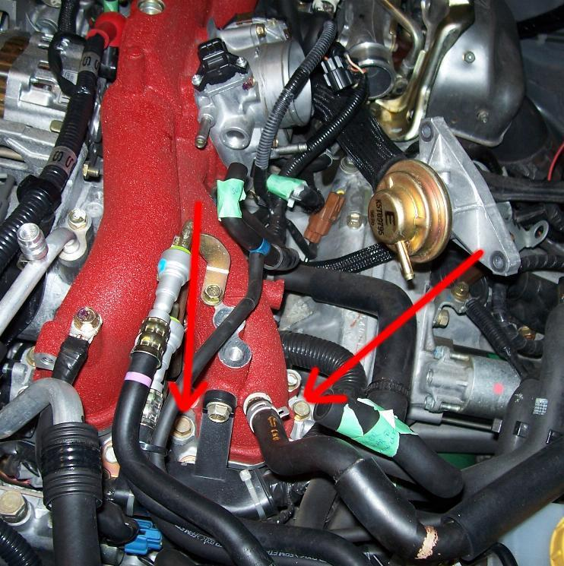
Just a note: its better to have 2 sets of hands when you lift it off so no damage occurs plus you need a second set of hands to untangle and lift out all the wiring harness so it doesn't get caught on anything while lifting the assembly off the motor and in case youve forgotten to undo any lines or wires.
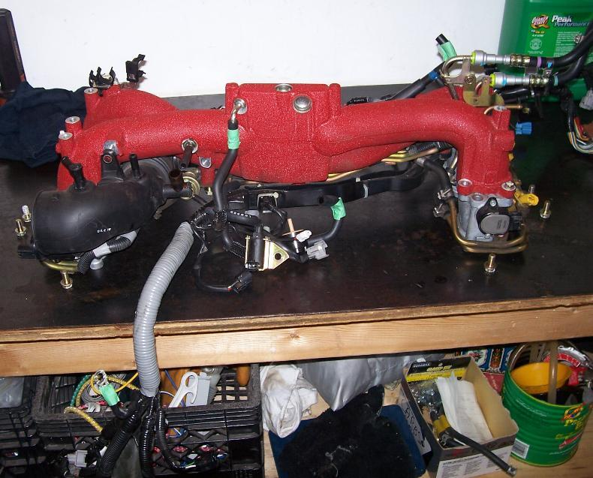
To reinstall just reverse. I will be reinstalling everything in a couple of weeks once I get my TGV's back from Kinger for porting.
P.S. I probably disconnected a few lines that didn't need to be undun just because there was a few I wasnt sure of. It's O.K. just reconnect them after.
__________________
MYBLOG
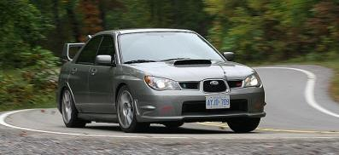

Last edited by jasv11 : 02-01-2007 at 07:17 PM.

